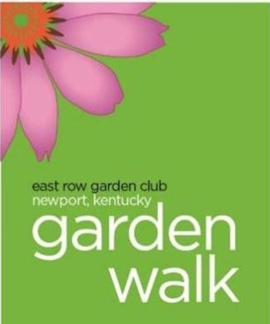 | East Row Garden Club  26th Annual Garden Walk  Newport’s Historic East Row Neighborhood  June 1 and 2, 2024

Sponsorships may be completed on line at www.eastrowgardenclub.org . Click the 2024 Garden Walk tab, and “be a Sponsor” in the lower right corner. If you prefer, you can mail this form to the address listed below.

Sponsorship donations and logo need to be provided by April 10th to be included on the poster.
The final date to provide Sponsorship for the Garden Walk is May 10th.

Name or Company Name:
Address:
Phone: | Email:
Website
Contact: | Signature:
Amount Donated:
Donor name as it’s to be printed:

Sponsorship Levels | Custom Distribution of Promotional Literature | Invitation to  After Party | Logo on Poster | Business Name on Ticket | Complimentary  Tickets
Platinum ($850+) | Yes | Yes | Large size | Yes | 6
Gold ($500-) |  | Yes | Large size | Yes | 4
Silver ($250 - $499) |  |  | Small size | Yes | 2
Bronze ($100 - $249) |  |  |  | Yes | 2
Copper ($50 - $99) |  |  |  |  | 2

Make checks payable to:  East Row Garden Club and mail to:  Karen Minzner  315 Park Av.  Newport, KY 41071 | Contact:  Karen Minzner  859-466-0767  kminzner@gmail.com

Thank you for your consideration and continued support of our organization.
The East Row Garden Club is a 501(c)(3) non-profit organization.

